# **UKG Information Guide**

**2023 Implementation**

# **LOGGING INTO UKG**

# **(Login info is the same for the computer & app)**

## **On the app –**

## Download the app UKG Pro Classic

## Logging in:

* 1. Company Access Code: gwequip
  2. Username: work email
  3. Password: DOB (mmddyyyy)

**Your new password will have a 16-character requirement.**

This can be a sentence or series of words.

Example – iloveSummer!2023! or Henry&johnny1117

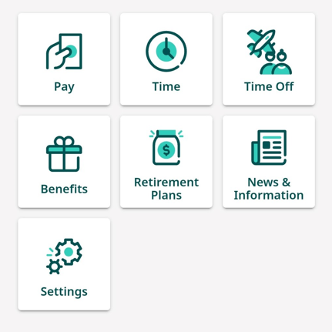

1. Create your Challenge Questions
2. Once you are logged in, you will be directed to your home screen.
3. This page can be personalized via the Settings tab using “Shortcuts”

## **On the website (Google Chrome is the recommended browser) –**

## Follow this [LINK](https://g035101p01x.ukg.net/login.aspx) (save this as a bookmark)

Your new password will have a 16-character requirement.

This can be a sentence or series of words.

Ex. iloveSummer2023! or Henry&johnny17

## Logging in:

* 1. Company Access Code: gwequip
  2. Username: work email
  3. Password: DOB (mmddyyyy)

1. Create your Challenge Questions

# **KEY INFORMATION AND DATES**

* Your paychecks and pay periods will remain the same.
* Your first pay period in UKG will be 10/23/23-11/3/2023, with your first UKG paycheck being 11/10/2023.
* PTO Accruals may look inaccurate until after your first paycheck has been run. We are going through finals reviews and will have this correctly listed by the 11/24/2023 payroll.

# **CLOCKING IN AND OUT**

# **Only Required if you are currently clocking into Paycom**

* **Technicians will continue to use Tinnacity**

## **On the app –**

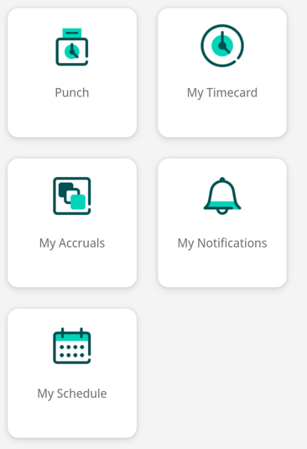 From your Home Screen > Punch > Clock In/Out

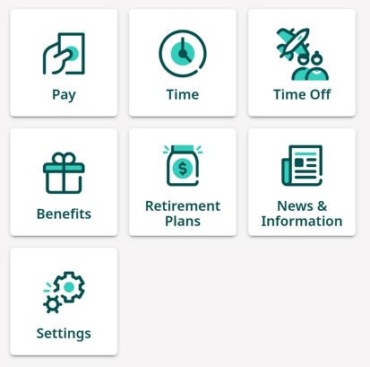

## **On the website (Google Chrome is the recommended browser) –**

From your Home Screen > Workforce Management > Punch

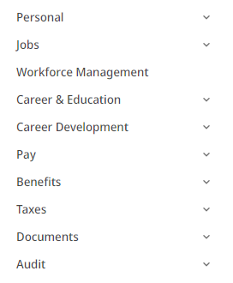

# **PERSONAL – This part is easier if done on the website**

## **Updating your personal information**

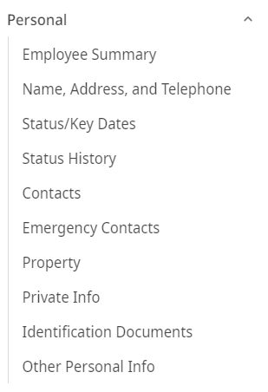From your Home Screen > Personal > Name, Address,

and Telephone > Edit > Update any information> Save

## **Adding Emergency Contacts**

**You will need to add your Emergency Contacts**

From your Home Screen > Personal > Emergency Contacts >

Add > Enter their information > Save

# **MY COMPANY**

## News & Information

Here, you will find any current events and news for G&W

# **SUPPORT**

You can reach out to the HR team with any questions.

HR Mailbox [hr@gwequip.com](mailto:hr@gwequip.com)

Kim Meltzer [kmeltzer@gwequip.com](mailto:kmeltzer@gwequip.com) 980.321.4656

Johana Barthle [jbarthle@gwequip.com](mailto:jbarthle@gwequip.com) 980.321.4607

Liliana Garzon [lgarzon@gwequip.com](mailto:lgarzon@gwequip.com) 704.394.6316

Kait Beck [kbeck@gwequip.com](mailto:kbeck@gwequip.com) 980.229.7050

David Fields [dfields@gwequip.com](mailto:dfields@gwequip.com) 770.324.0089

**Pulling Information from Paycom –** This is Not Required!

We did not bring over historical data from Paycom, except for 2023 Payroll and Tax totals. G&W HR will have access to your past checks, W2s, and 1095s for 7-years. However, you will only have access to Paycom through mid-January 2024.

If you’d like to download these items onto your personal devices before Paycom goes away, please follow the following directions:

## **Your Pay Stubs**

Open Paycom > Payroll tab > View Pay Stubs > Select the year you want to download > Click the box to select all Pay Stubs > Select Print Pay Stubs > Download them to whichever device you prefer or print them.

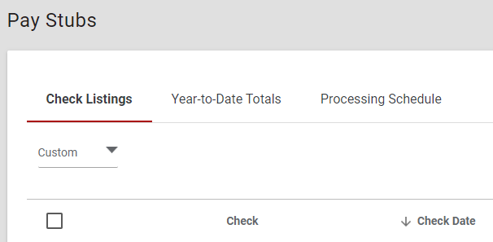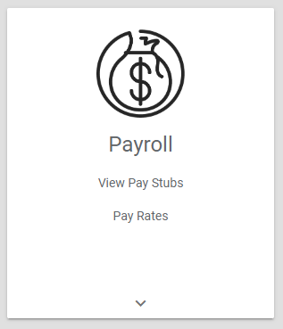



To select all, click this box.

# 

## **Your Year End Tax Forms**

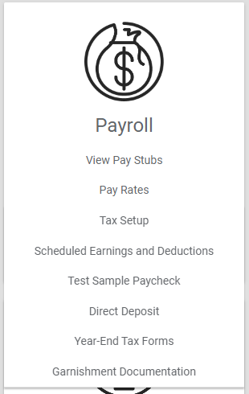

Open Paycom > Payroll tab > Year-End Tax Forms > When you click the View button, it will automatically download the document to your device.